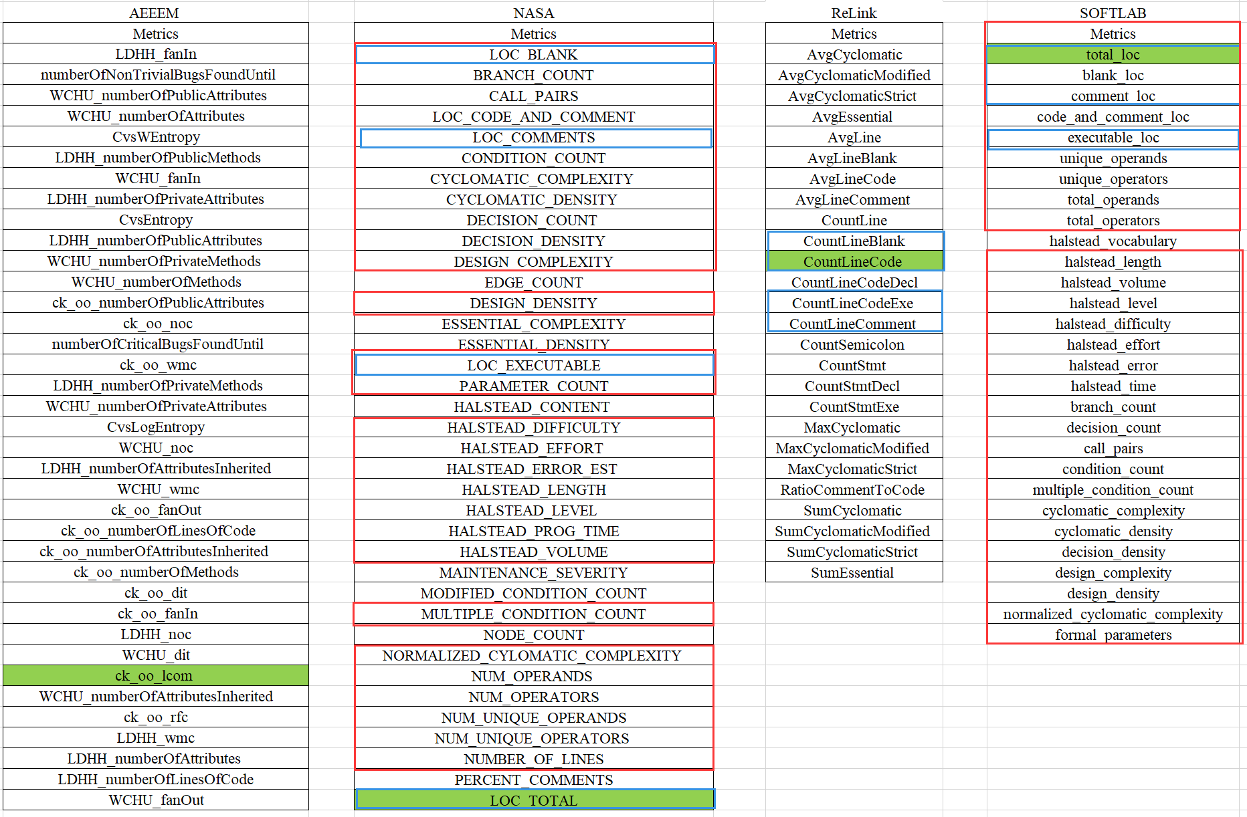

Figure 1. List of the metrics used from four companies.

The detailed metrics in Figure 1 are from AEEEM, NASA, ReLink and SOFTLAB respectively. The common metrics between NASA and SOFTLAB are labeled by red box, and the number of common metrics is 28. The common metrics between NASA and ReLink are labeled by blue box, and the number of common metrics is 4. The common metrics between SOFTLAB and ReLink are labeled by blue box, and the number of common metrics is 4. The common metric between AEEEM and other three datasets is labeled by green background, and the number of common metric between AEEEM and NASA, ReLink and SOFTLAB is 1, 1 and 1.